Panel Advisor:

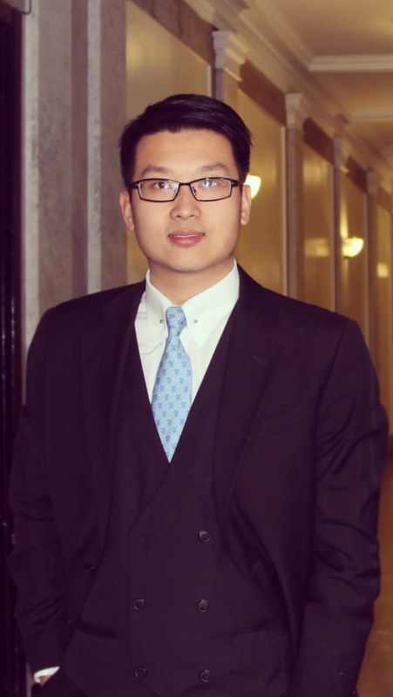

Weizhi Shao

Ph.D candidate in Earth and Environmental Engineering

Fu Foundation School of Engineering

ws2303@columbia.edu

Panel Director:

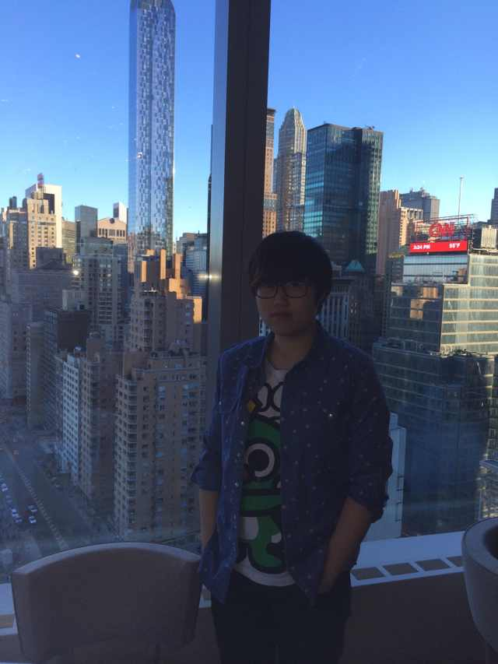

Ze Peng

M.S. Candidate of 2014

Electrical Engineering

Fu Foundation School of Engineering

Club Manager of CUCSSA Entrepreneurship and Investment Club

zp2151@columbia.edu

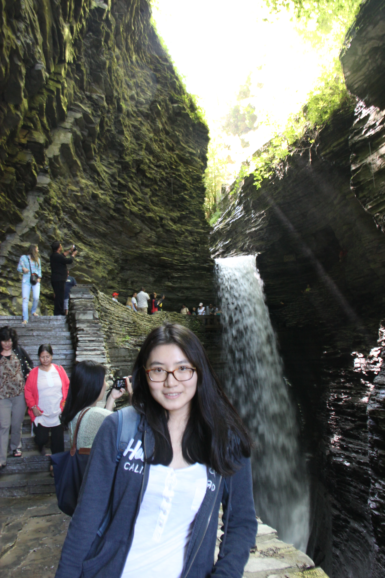

Xiaodan Wang

MS candidate 2015

Applied Statistics, Teachers College

[xw2309@tc.columbia.com](mailto:xw2309@tc.columbia.com)

Panel Associate:



Coco, Yirong Xu

M.S. Candidate of 2014

Communication Practices

School of Continuing Education

[yx2269@columbia.edu](mailto:yx2269@columbia.edu" \t "_blank)

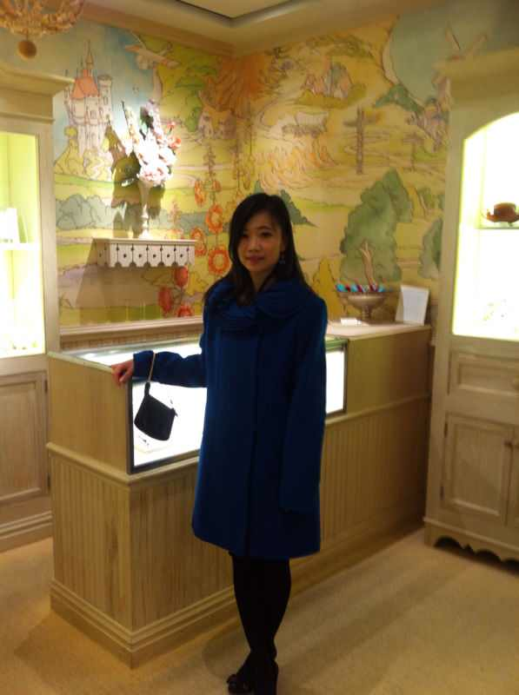

Sai Zhang

M.S. Candidate 2015

Department of industrial engineering and operations research

[sz2418@columbia.edu](mailto:sz2418@columbia.edu)

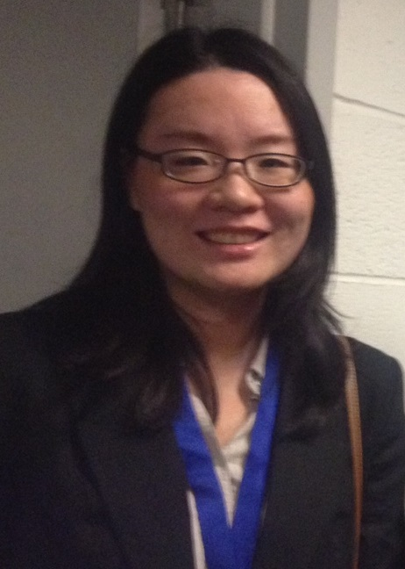

Ju Yang

Ph.D. Candidate 2017

Department of Biological Sciences

Graduate School of Art and Sciences

[jy2487@columbia.edu](mailto:jy2487@columbia.edu" \t "_blank)